Literacy NY Executive Director News: November 2025

Hello, everyone. Hope you are staying cozy as we move into the chilly weather! We had a little snow here in Buffalo this week.

Upcoming Board Calls/Meetings:
- Thursday, December 11, 2025: 9:30 to 10:30am; Zoom
- Thursday, March 12, 2026: 9:30 to 10:30am; Zoom

Here is the latest from Literacy New York– I’ve tied activities back to our Strategic Action Plan goals. Reach out with comments and questions!

Goal: Literacy NY will continually evaluate current activities and assess future activities to maximize opportunities for the organization
ALE
ALE funds still have not been distributed to award recipients, as we reach our fifth month of operations for the program year. For many of the local service providers, this delay is starting to really hit them hard. Literacy NY is fortunate to remain in a positive cash position. Suzanne ran the numbers, and we can cover 11 months of operations without the ALE funds, and 7 months without liquidating our investments. (Happy to share the report– just email me.) We have been pushing AEPP leadership for details on where the hold up is, but have not received much information. First, we were told that things are held up in the Contracts Dept. of State Ed, then the Comptroller’s Office. The latest is that the shift of adult education services from the US Dept. of Education to the US Dept. of Labor at the federal level is to blame. Because our funding is state money, we’re not seeing how this is affecting ALE. Local programs are beginning to reach out to their legislators for help in moving the funds.
Estate Distribution
Literacy NY recently received a sizable bequest from the estate of a woman named Marilyn Mielke. The amount is $100,000. We are tremendously grateful to her for remembering Literacy NY in her will. We will be having a quick online board meeting very soon to authorize me to accept the funds on Literacy NY’s behalf– watch out for a Doodle Poll– and we’ll discuss what we’ll do with these funds at our December board meeting. Certainly the largest gift I’ve seen in my tenure here!

Goal: LNY will serve as a catalyst to advance adult literacy
ALE Regional Meetings and Site Visits
We concluded our 6 ALE Regional Meetings this month— the meetings started in September, and took us from Western NY to Long Island and all regions in between! This deliverable in our ALE/STAC contract is a favorite of mine, giving me the opportunity to connect in smaller groups with each of the directors of the ALE funded programs. Our AEPP Regional Representative, Miranda Prime, was able to attend 5 of the 6 meetings, and we also had additional AEPP staff and RAEN Directors join us across the state. I welcome the AEPP and RAEN folks, as it offers me an opportunity to highlight the work of the STAC, shine a spotlight on our online tutor training and other supports, and gives the ALE programs a chance to talk directly with state leadership.
I’ve also made site visits to numerous programs with our AEPP Regional and the NYS Accountability office this fall, and they have all been positive. Our ALE funded programs did well in meeting and exceeding benchmarks last program year, and they are looking good this year (even with zero ALE dollars!!). That makes the site visits enjoyable for all.
COABE Conference 2026
I’ve been accepted to present at the 2026 COABE National Conference in Indianapolis, IN scheduled for spring of 2026! I’m looking forward to this opportunity to engage in quality professional development, to connect with colleagues, and to offer a workshop to my peers. It is always a valuable time.
Literacy Suffolk Award
Literacy NY was the recipient of Literacy Suffolk’s “Supporting Partnership Award” at their recent Fall Fundraiser. Literacy Suffolk is one of the programs currently supported with our STAC project, and we have had a relationship with the program for decades. These words are from the awards ceremony:
“True partnership is built on trust, support, and shared dedication– and in Kathy, Kitty, and Mary Jo, we’ve found not only colleagues but true partners and friends. Their commitment, encouragement, and problem-solving spirit have been invaluable.”
We look forward to many more years of partnership with Literacy Suffolk!

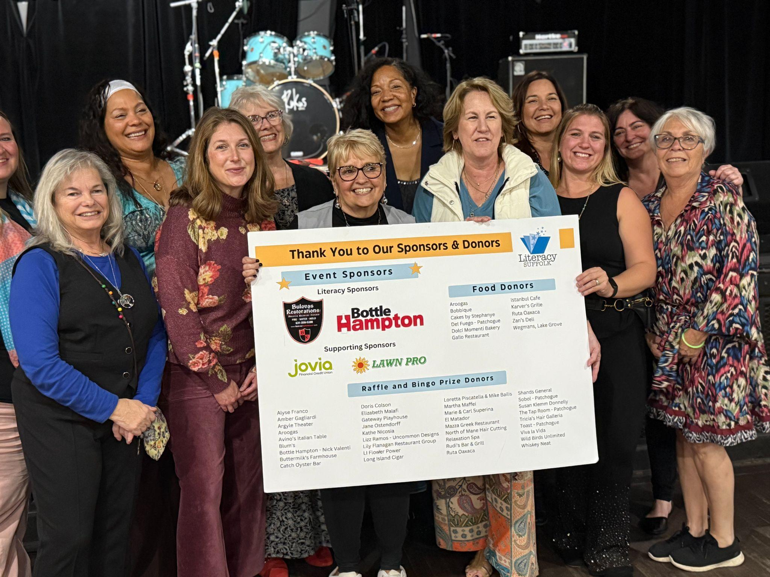

Goal: The Board of Literacy New York, Inc. will diversify and strengthen board members’ contributions and commitment to the Mission of LNY
Pat Rajala, in her role as Chair of Literacy NY’s Governance Committee, has been busy working to build board membership. We have identified a great potential board member, Tara Schafer, Executive Director at Literacy Buffalo Niagara, and will be submitting her name for consideration by the board after January 1. We are also talking with the president and the vice president of the Northern NY Community Foundation next week about Literacy NY and board service opportunities. Please continue to provide Pat with leads!

Best,
Kathy

- “The more you practice the art of thankfulness, the more you have to be thankful for.” — Norman Vincent Peale

Abbreviations and acronyms:
AEPP: Adult Education Policy and Procedures; governs adult education programming in NYS, including ALE
ALE: Adult Literacy Education; Literacy NY’s main line of funding; supports STAC project
ASISTS: Adult Student Information System and Technical Support; the database that houses program data in NYS
CBO: Community Based Organization
ELL: English Language Learners
HSE: High School Equivalency
MWBE: Minority and Women-owned Business Enterprises; a NYS program that encourages grantees to utilize MWBE vendors in fulfilling contracts and grants
NYRS: New York’s Reporting System; the system of accountability under which ALE funded direct service providers work
NYSED: NY State Education Department
RAEN: Regional Adult Education Network; provide professional development to adult ed practitioners
RFP: Request for proposal; document that solicits proposal, often made through a bidding process
STAC: Support and Technical Assistance Center; LNY is funded as the Rest of State New York STAC, providing technical assistance to ALE-funded programs
GED: NYS’s high school credential exam
WIOA: Workforce Innovation and Opportunity Act; the federal funding stream administered by the state supporting LNY’s Regional Adult Education Networks (as well as direct service providers)
MWBE: Minority and Women Owned Business Enterprises
I2O: Intake to Outcomes; Literacy NY’s online training platform for ALE funded programs
OTT: Online Tutor Training; Literacy NY’s online training platform for users outside of the ALE cohort

Organizations:
NYACCE: New York Association for Continuing and Community Education; the voice for adult education programs in NYS
NYATEP: New York Association of Training and Employment Professionals
LAC: Literacy Assistance Center; our STAC counterpart in NYC
NYCCAL: NYC Coalition for Adult Literacy; our advocacy partner in NYC
BOCES: Boards of Cooperative Education; BOCES house adult education programs across the state
LINCS: Literacy Information and Communication System (LINCS); a national leadership initiative of the U.S. Department of Education
COABE: Coalition on Adult Basic Education
CSO: Council of State Organizations: A group of state directors of volunteer-based adult literacy programs and ProLiteracy
ProLiteracy: The largest adult literacy and basic education membership organization in the nation (https://www.proliteracy.org/)
OCTAE: Office of Career, Technical, and Adult Education; federal Dept. of Ed for adult education providers

