**Literacy NY Executive Director News: July 2025**

Hello, everyone. Hope everyone is enjoying the summer!

Upcoming Board Calls/Meetings:

* Thursday, September 11, 2025; Zoom
* Thursday, December 11, 2025; Zoom

Here is the latest from Literacy New York– I’ve tied activities back to our Strategic Action Plan goals. Reach out with comments and questions!

**Goal: Literacy NY will continually evaluate current activities and assess future activities to maximize opportunities for the organization**

ALE

As I announced via email, Literacy NY was awarded the Rest of State Support and Technical Assistance Center (STAC) grant under the Adult Literacy Education (ALE) funding stream. We have not yet received a contract or seen the approved budget. A number of programs that were funded this year (including our counterpart STAC in NYC) were funded short of the total amounts requested. Our award letter is short by about $23,000 per year, and I’ve requested details– still waiting for that information. Most of the Rest of State programs we support were funded again– we had 23 contracts we were supporting last cycle, and we have 22 this cycle. (Some contracts are consortia, and represent more than one adult literacy provider.) We have one new program in the Hudson Valley region, and one of our consortium programs split, creating an additional contract. Three proposed contracts from our network were not funded this round, and we will miss working with those programs under the ALE umbrella– we will work to continue to maintain relationships via online tutor training.

Online Tutor Training

We are pleased to share that the Adult Learning Alliance of Arkansas has decided to use our Online Tutor Training in their literacy councils across the state! We did a successful pilot with a couple of their councils through the Janice Cuddahee Fund, and are excited to continue working with this group. They are starting with 300 workshops, bringing in $7500 in income for Literacy NY. Kitty and I held a couple of Zoom orientation sessions with them, and Kitty is working to get them everything they need to get going with the training– a big job, and we appreciate her efforts!

**Goal: LNY will serve as a catalyst to advance adult literacy**

Greek Peak Conference 2025

We hosted about 60 participants at June’s Greek Peak Conference, representing the majority of the adult literacy programs we support through our STAC grant. As you can see in the chart below, respondent’s expectations were met or surpassed, which we love to hear.

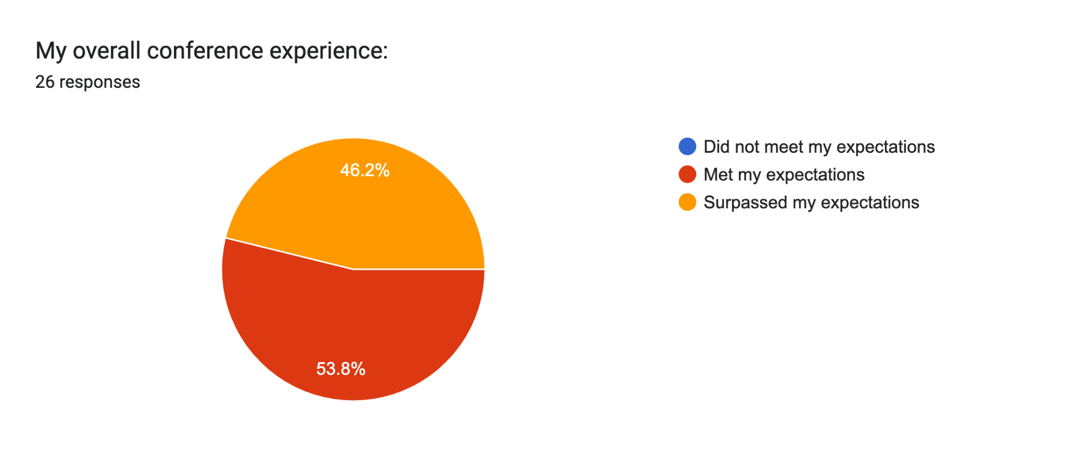

The Breakout Sessions were well received, and participants appreciated the information presented. As much as the content shared in the workshops, however, individuals liked interacting with and hearing from one another. We heard “The roundtable was very engaging. Being able to hear not only from presenters, but from the group as a whole helped” and “As always it's a great group with great people. I always enjoy time to pick the brains of other programs!” They also appreciated the atmosphere we intentionally created, with comments like “I appreciated the down time- no rush”; “The flow of the day was great”; and “Trivia was a blast. I love time bonding with other programs!” Kudos to Kitty for all of the planning, and Mary Jo and Suzanne for their great support during the conference. We are on the books for next June!

Literacy Buffalo Niagara Invitation

Our friends and colleagues at Literacy Buffalo Niagara invited me to be a part of their Strategic Planning Committee. It is an honor to be asked, and I’m learning a lot in the process. They are working with a great group, and a really good consultant– I’m enjoying the experience.

**Goal: The Board of Literacy New York, Inc. will diversify and strengthen board members’ contributions and commitment to the Mission of LNY**

We enjoyed meeting our two new board members at the June meeting. It was really great to see people “in real life” after a year of Zoom meetings! Kitty and I are working on updating the board charts, etc. We need to hear from everyone before we assign board members to the committees– I believe we are still waiting for some information from a couple of folks via the Board Engagement Form. If Kitty has reached out to you, please send in your form so that we can get everything updated–thanks!

I will be out of the office next week, 7/15 to 7/18.

Best,

Kathy

*““Summer afternoon—summer afternoon; to me those have always been the two most beautiful words in the English language.” Henry James*

Abbreviations and acronyms:

AEPP: Adult Education Policy and Procedures

ALL IN: Adult Literacy and Learning Impact Network; a collective impact initiative charged with carrying out the National Action Plan for Adult Literacy

ASISTS: Adult Student Information System and Technical Support; the database that houses program data in NYS

CBO: Community Based Organization

ELL: English Language Learners

HSE: High School Equivalency

MWBE: Minority and Women-owned Business Enterprises; a NYS program that encourages grantees to utilize MWBE vendors in fulfilling contracts and grants

NYRS: New York’s Reporting System; the system of accountability under which ALE funded direct service providers work

NYSED: NY State Education Department

RAEN: Regional Adult Education Network; LNY holds contracts for these programs in Western NY and in the Capital/North Region. RAENs offer professional development to adult education teachers and practitioners.

RFP: Request for proposal; document that solicits proposal, often made through a bidding process

STAC: Support and Technical Assistance Center; LNY is funded as the Rest of State New York STAC, providing technical assistance to ALE-funded programs

GED: NYS’s high school credential exam

WIOA: Workforce Innovation and Opportunity Act; the federal funding stream administered by the state supporting LNY’s Regional Adult Education Networks (as well as direct service providers)

MWBE: Minority and Women Owned Business Enterprises

I2O: Intake to Outcomes; Literacy NY’s online training platform for ALE funded programs

OTT: Online Tutor Training; Literacy NY’s online training platform for users outside of the ALE cohort

Organizations:

NYACCE: New York Association for Continuing and Community Education; the voice for adult education programs in NYS

NYATEP: New York Association of Training and Employment Professionals

LAC: Literacy Assistance Center; our STAC counterpart in NYC

NYCCAL: NYC Coalition for Adult Literacy; our advocacy partner in NYC

BOCES: Boards of Cooperative Education; BOCES house adult education programs across the state

LINCS: Literacy Information and Communication System (LINCS); a national leadership initiative of the U.S. Department of Education

COABE: Coalition on Adult Basic Education

CSO: Council of State Organizations: A group of state directors of volunteer-based adult literacy programs and ProLiteracy

ProLiteracy: The largest adult literacy and basic education membership organization in the nation (<https://www.proliteracy.org/>)

OCTAE: Office of Career, Technical, and Adult Education; federal Dept. of Ed for adult education providers